**Soursop Punch**

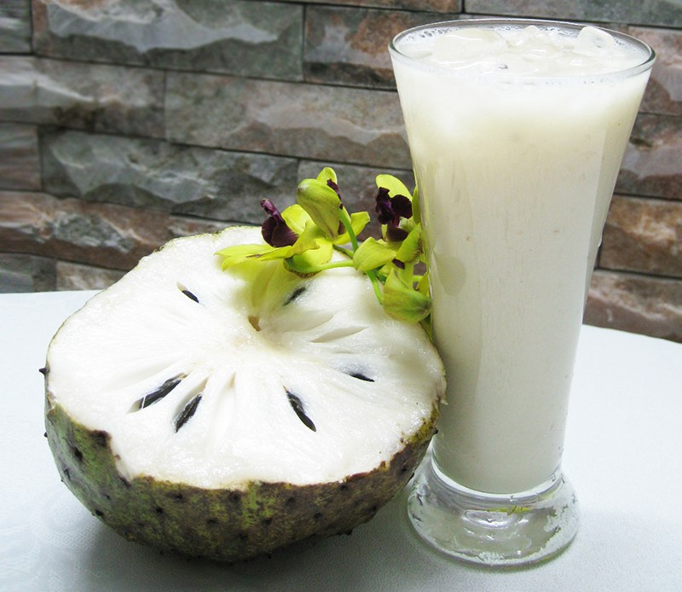

**INGREDIENTS**

1 large soursop peeled

2 ½ cup of almond milk

1 jar of condensed coconut milk see post

1 teaspoon vanilla extract

¼ teaspoon nutmeg

½ teaspoon cinnamon

**METHOD**

1. Cut the peeled soursop lengthways into two halves.
2. Use a knife to discard the thick stalk running down the middle of the fruit.
3. Cut the flesh into small pieces using the same knife to pluck out the black seeds. Feel free to use your fingers if preferred. This process should take approximately 10 minutes to complete.
4. Place the thick pulp into a high speed blender followed by the almond milk, vanilla, nutmeg, cinnamon and homemade condensed coconut milk.
5. Blitz into a smooth thick consistency
6. Serve accordingly